UNIT-5

ANALYTICAL GEOMETRY

**Conic Section**

A conic section is the intersection of a plane and a cone. By changing the angle and location of intersection, we can produce a circle, ellipse, parabola or hyperbola; or in the special case when the plane touches the vertex: a point, line or 2 intersecting lines.

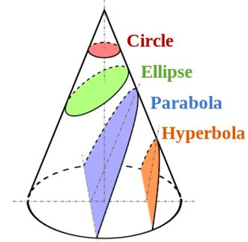

**Circle**

A round plane figure whose boundary (the circumference) consists of points equidistant from a fixed point (the center).

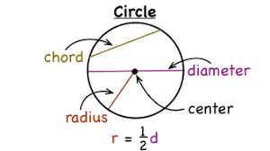

**Eclipse**

An ellipse is the locus of the point such that its distant from

the focus bears the constant ratio to the distance from the

line called directrix. the value of eccentricity lies between the 0 and 1

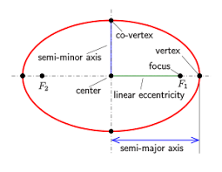

**Hyperbola**

A hyperbola is set of all points in a plane such that the difference of the distances from the two fixed points called foci is a constant.

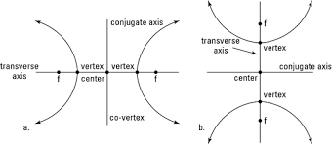

**Parabola**

The parabola is the curve formed from all the points that are equidistant from the directrix and the focus.

Focal distance: The distance of any point on parabola from the focus is called focal distance.

Focal chord: Any chord of the parabola passing through the focus is called focal chord.

Latus Rectum: The focal chord which is perpendicular to the axis is called latus rectum.

Equation of parabola in standard form is y=4ax2

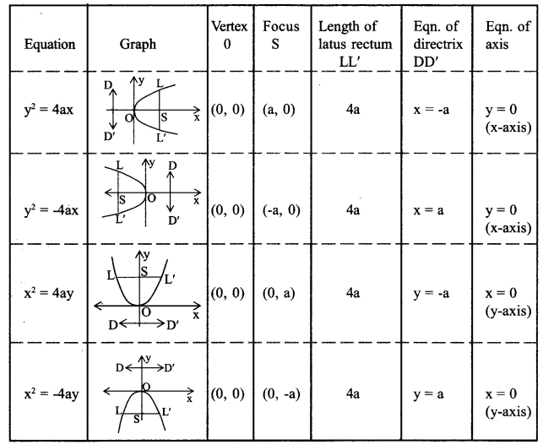

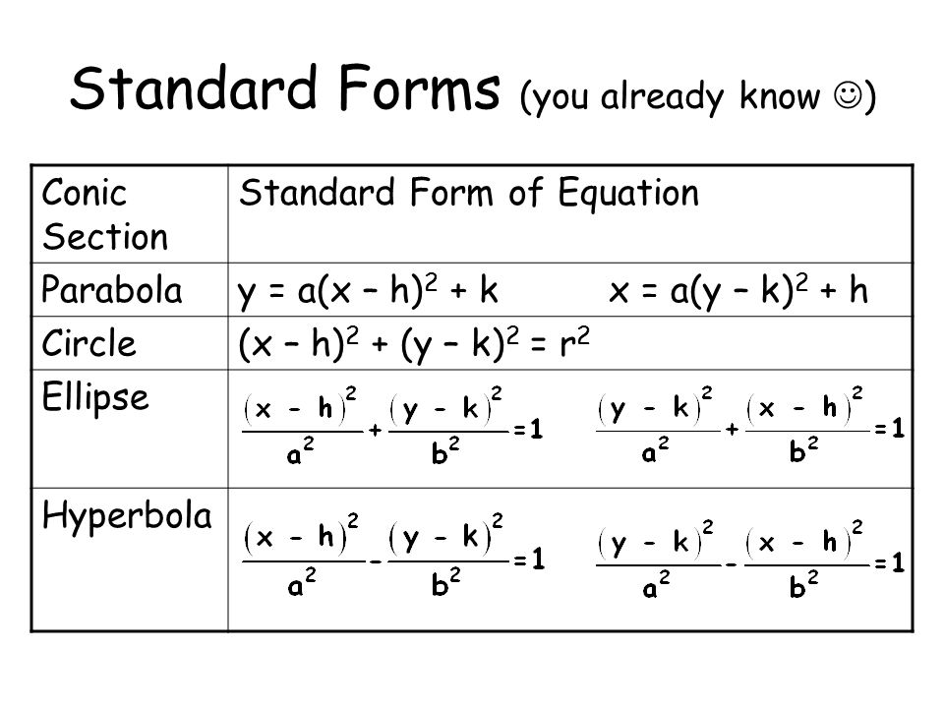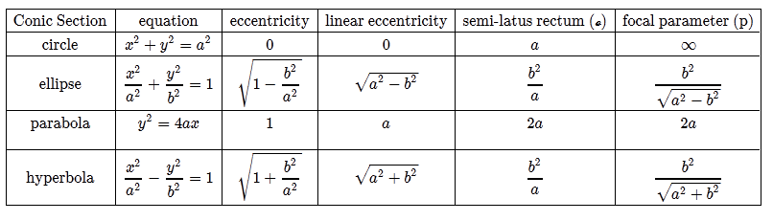

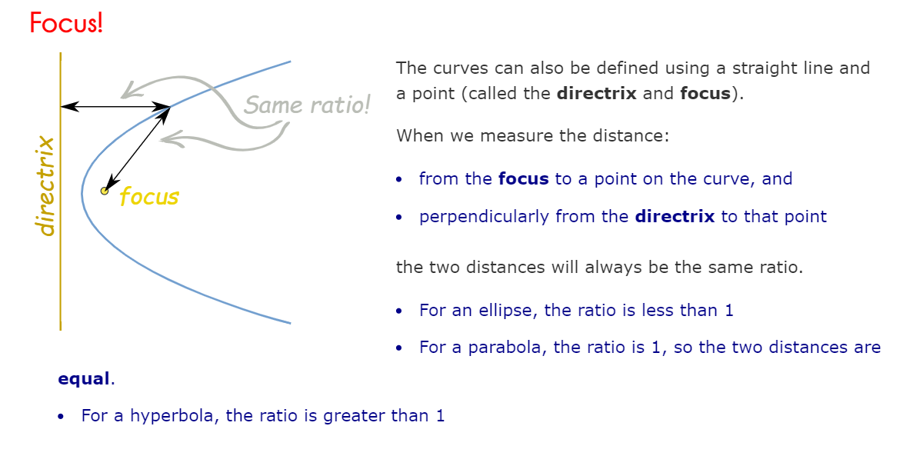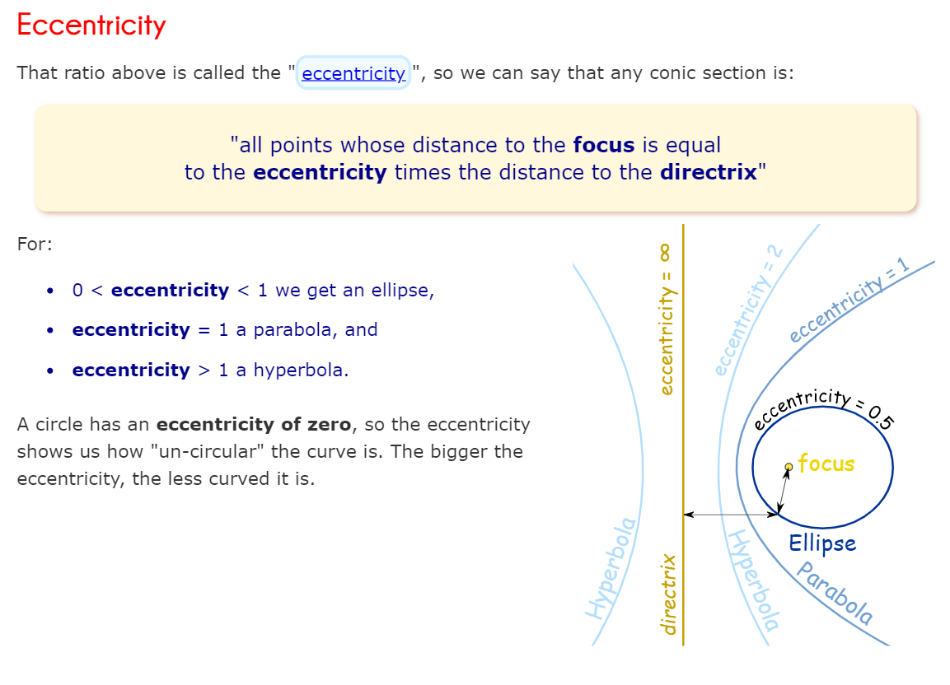

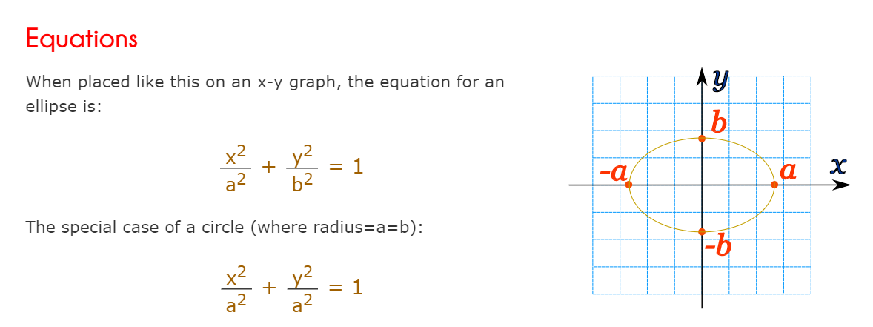 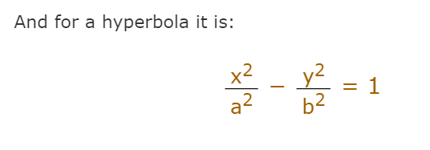 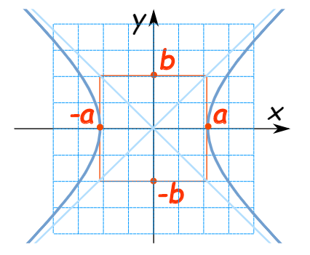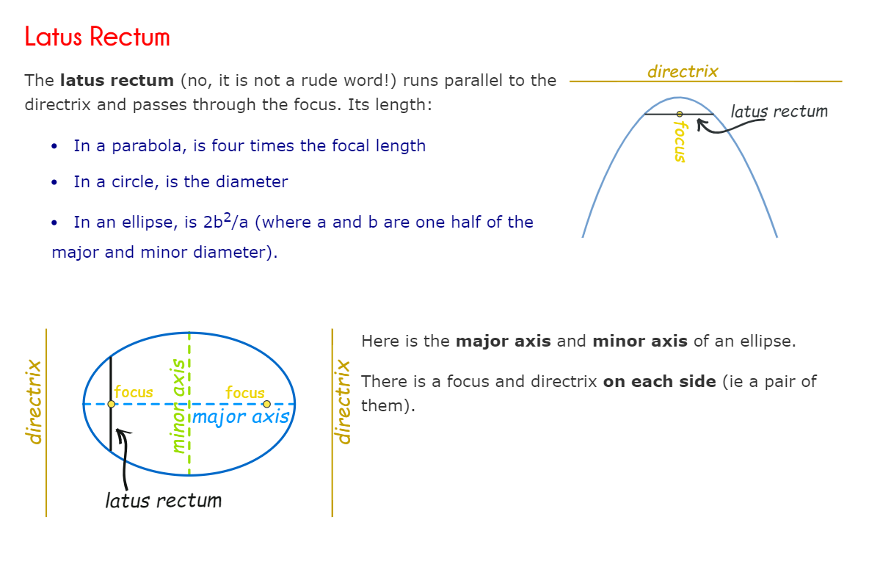

**General Equation**

We can make an equation that covers all these curves.

Because they are plane curves (even though cut out of the solid) we only have to deal with [Cartesian ("x" and "y") Coordinates](https://www.mathsisfun.com/data/cartesian-coordinates.html).

But these are not straight lines, so just "x" and "y" will not do ... we need to go to the next level, and have:

* **x2** and **y2**,
* and also **x** (without y), **y** (without x),
* x and y together (**xy**)
* and a constant term.

There, that should do it!

And each one needs a factor (A,B,C etc) ...

So the **general equation** that covers all conic sections is:

Ax^2 etc

And from that equation we can create equations for the circle, ellipse, parabola and hyperbola.

**Vector in space**

**Vector**

The vectors are defined as an object containing both magnitude and direction. Vector describes the movement of an object from one point to another.  **Vector math** can be geometrically picturized by the directed line segment. The length of the segment of the directed line is called the [magnitude of a vector](https://byjus.com/maths/magnitude-of-a-vector/) and the angle at which the vector is inclined shows the direction of the vector. The beginning point of a vector is called “Tail” and the end side (having arrow) is called “Head.”

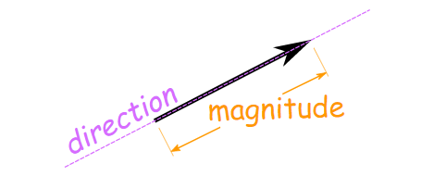

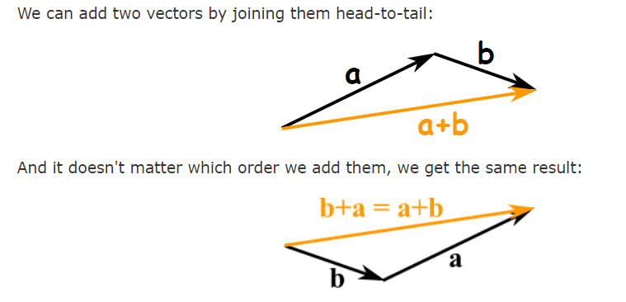

**Subtracting**

We can also subtract one vector from another:

* first we reverse the direction of the vector we want to subtract,
* then add them as usual:

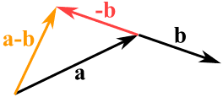

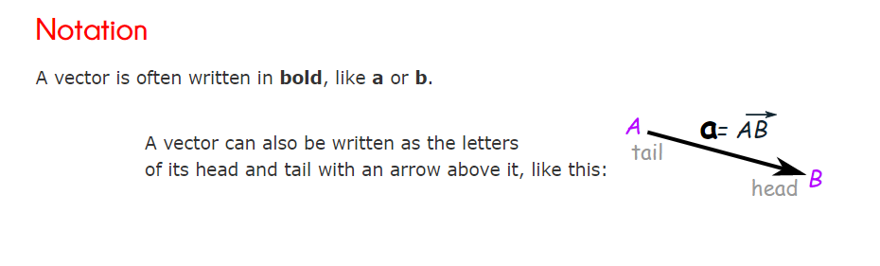

## Adding Vectors

We can then add vectors by **adding the x parts** and **adding the y parts**:

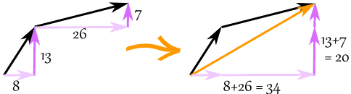

The vector (8,13) and the vector (26,7) add up to the vector (34,20)

### **Example: add the vectors**a**= (8,13) and**b**= (26,7)**

**c** = **a** + **b**

**c** = (8,13) + (26,7) = (8+26,13+7) = (34,20)

## Subtracting Vectors

To subtract, first reverse the vector we want to subtract, then add.

### **Example: subtract**k**= (4,5) from**v**= (12,2)**

**a** = **v** + −**k**

**a** = (12,2) + −(4,5) = (12,2) + (−4,−5) = (12−4,2−5) = (8,−3)

## Magnitude of a Vector

The magnitude of a vector is shown by two vertical bars on either side of the vector:

|**a**|

OR it can be written with double vertical bars (so as not to confuse it with absolute value):

||**a**||

We use [Pythagoras' theorem](https://www.mathsisfun.com/pythagoras.html) to calculate it:

|**a**| = √( x2 + y2 )

### **Example: what is the magnitude of the vector**b**= (6,8) ?**

|**b**| = √( 62 + 82) = √( 36+64) = √100 = 10

A vector with magnitude 1 is called a [Unit Vector](https://www.mathsisfun.com/algebra/vector-unit.html).

## Multiplying a Vector by a Scalar

When we multiply a vector by a scalar it is called "scaling" a vector, because we change how big or small the vector is.

### **Example: multiply the vector**m**= (7,3) by the scalar 3**

|  |  |  |
| --- | --- | --- |
| vector scaling |  | **a** = 3**m** = (3×7,3×3) = (21,9) |

It still points in the same direction, but is 3 times longer

(And now you know why numbers are called "scalars", because they "scale" the vector up or down.)

### **Scalar Multiplication**

Multiplication of a vector by a scalar quantity is called “Scaling.” In this type of multiplication, only the magnitude of a vector is changed not the direction.

* S(a+b) = Sa + Sb
* (S+T)a = Sa + Ta
* a.1 = a
* a.0 = 0
* a.(-1) = -a

### **Vector Multiplication**

It is of two types “**Cross product**” and “**Dot product**.”

### **Cross Product**

The cross product of two vectors results in a vector quantity. It is represented by a cross sign between two vectors.

**a × b**

The mathematical value of a cross product-

Cross Product

where,

| a | is the magnitude of vector a.

| b | is the magnitude of vector b.

θ is the angle between two vectors a & b.

and n^ is a unit vector showing the direction of the multiplication of two vectors.

### **Dot product**

The dot product of two vectors always result in scalar quantity, i.e. it has only magnitude and no direction. It is represented by a dot in between two vectors.

a. b

The mathematical value of the dot product is given as

|  |
| --- |
| a . b = | a | | b | cos θ |

**IF A= A x ax+ A yay + Azaz**

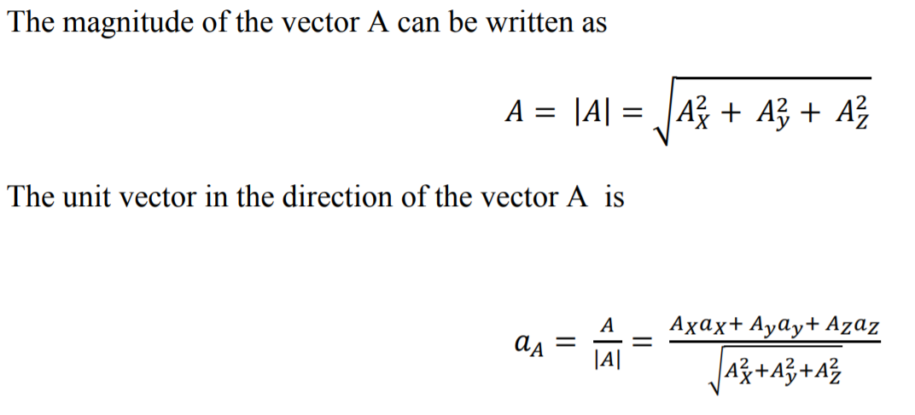

**Unit Vector**

A unit vector is defined as a vector in any specified direction whose magnitude  
is unity i.e. 1. A unit vector only specifies the direction of a given vector.   
In three dimensional coordinate system unit vectors  having the direction of the positive X-axis, Y-axis and Z-axis are used as unit vectors. These unit vectors are mutually perpendicular to each other.

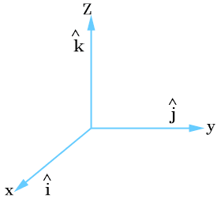

**Null Vector**

|  |
| --- |
| A null vector is a vector having magnitude equal to zero. It is represented by . A null vector has no direction or it may have any direction. Generally a null vector is either equal to resultant of two equal vectors acting in opposite directions or multiple vectors in different directions. |
|  |